**Example: When to pull the goalie in hockey**

When his team is behind late in the game, a hockey coach usually waits until there is one minute left before pulling the goalie out of the game. Using simulation, it is possible to show that coaches should pull their goalies sooner. Suppose that if both teams are at full strength, each team scores an average of 0.05 goal per minute. Also, suppose that if you pull your goalie you score an average of 0.08 goal per minute and your opponent scores an average of 0.12 goal per minute. Suppose you are one goal behind. Compare the following two strategies:

* Pull your goalie if you are behind at any point in the last minute of the game; put him back in if you tie the score.
* Pull your goalie if you are behind at any point in the last two minutes of the game; put him back in if you tie the score.

Simulate the game using 10-second increments of time. Use the RISKBINOMIAL function to determine whether a team scores a goal in a given 10-second segment. This is reasonable because the probability of scoring two or more goals in a 10-second period is near zero.

**Which strategy provides a higher probability of winning or tying the game?**

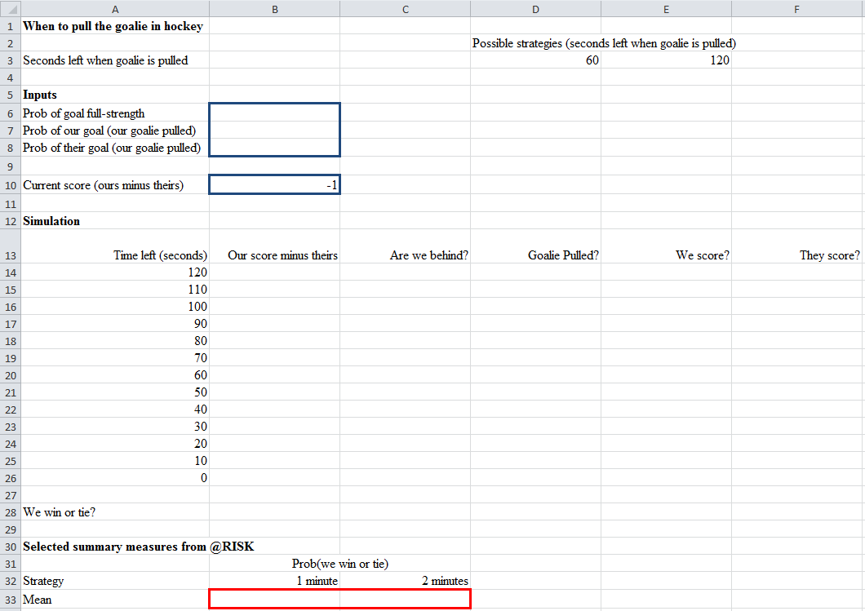**Specify the following @Risk Model in Excel:**

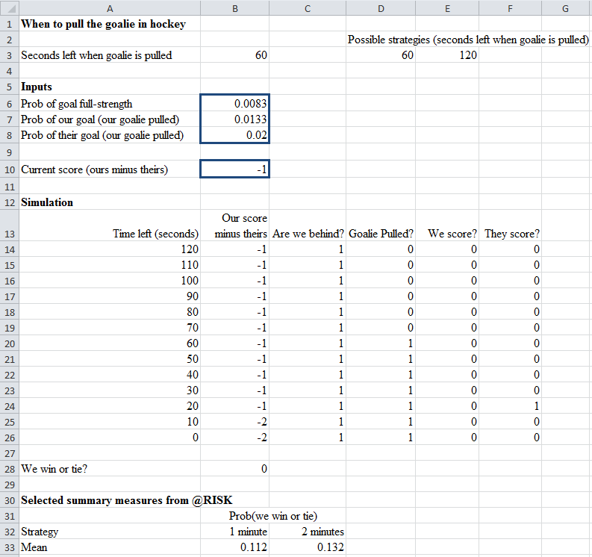**Results:**

Which strategy provides a higher probability of winning or tying the game?

The strategy of pulling with 2 minutes to go seems to increase the probability slightly of us winning or tying.